Infiheal Test Platform — May vs June Performance Report
Reporting period: May 2026 (whole month average) vs June 2026 (week-by-week)
Data coverage: May — 20 of 31 days available (gaps: May 2–5, May 20–25)

1. Onboarding & Funnel Health
Metric | May (month avg) | Jun Wk1 (2–7) | Jun Wk2 (8–14) | Jun Wk3  (15–20)
SEO Traffic | 266/day | 294/day | 267/day | 236/day
Healo Traffic | 232/day | 248/day | 35/day | 44/day
Tests Started | 192/day | 217/day | 195/day | 183/day
Tests Completed | 254/day | 324/day | 233/day | 218/day
Completion Rate | 132% | 149% | 120% | 119%
Landing→Start Rate | 39% | 40% | 67% | 66%

(So every single day, we are getting test completions from: People who started and finished that same day, People who started yesterday (or earlier) and finished today)
May had unusually high Healo traffic (232/day), driving strong completion volume despite a low Landing→Start rate (39%).
The signup wall hit rate, climbing from 27% to 62%, is mainly a consequence of fewer logged-in Healo users completing tests.

2. Test Completion Performance

Allosexual and Asexual remain the two highest-volume, lowest-completing tests across both months.
June only (Jun 8–15, 8 days)
Test | Starts | Finishes | Completion Rate
Asexual | 545 | 256 | 47.0%
Allosexual | 269 | 119 | 44.2%
Love Test | 167 | 123 | 73.7%
Inkblot | 141 | 123 | 87.2%

(If the users don’t submit due to the signup wall)

. Users want the result immediately.
. Not ready to put more effort after a decently long test

(If the users are leaving in between the questions)

. The test is too long.
. The questions become uncomfortable (very deep or overwhelming)

3. Retention & Return Behavior
Metric | May (month avg) | Jun Wk1 | Jun Wk2 | Jun Wk3
Return Users (already logged in at submission) | 34/day | 40/day | 64/day | 55
Signups Completed | 112/day | 121/day | 92/day | 86
Return users grew through June, a genuinely positive signal. Signups completed declined steadily — fewer new users converting to verified accounts, even as existing users engage more.

4. Healo Chat Engagement
Metric | May (month avg) | Jun Wk1 | Jun Wk2 | Jun Wk3
Total User Messages | 299/day | 242/day | 152/day | 285
New unique signups Who Sent ≥1 Message | 11.3/day | 8.7/day | 6.3/day | 10.8
Engage Rate (msg senders/signups completed) | 10.4% | 7.9% | 7.0% | 12.8%
Most concerning trend in the report. Engage Rate has declined steadily across three consecutive periods — roughly 9 out of 10 signups never send a single message, and that ratio has been worsening.
5. Anomalies Flagged
- Healo traffic collapse. 232/day → 35/day by Week 2, no recovery. Root cause behind most other negative shifts in this report.
- Engage Rate — U-shaped, not a steady decline. Dropped May→Wk2, recovered strongly in Wk3. Needs more days before drawing a firm conclusion.
- SEO spike on Jun 13 (single-day, resolved). 437 visitors vs ~260 weekly average, Landing→Start dropped to 41% that day.
- Signup Wall Hit Rate more than doubled (27% → 62%). Traffic-mix effect from fewer logged-in Healo users (definitely not a UI/UX problem)
Also, over 3 weeks of June, the unique users per day average for each of the week was consistent (48.5 => 32 => 44.5)

Act On:
Investigate the Healo traffic collapse immediately — the root cause behind weakened signups and higher wall rate.
Engage Rate decline needs a product fix — stronger first-message prompt or in-test nudge into Healo chat.
Allosexual and Asexual remain the biggest recoverable opportunity —flat-to-declining completion despite the highest traffic volume.

Is the Daily Mail Sufficient?
1. Retention Cohorts (Day 1 / Day 7 / Day 30)
What's missing: Of users who signed up on a given day, what % were still active 7 days later, 30 days later?
Why the Daily Mail can't do this: "Return Users" in your daily mail just counts logged-in submissions that day — it can't tell you which signup cohort they belong to or trace an individual user's lifecycle.

2. Time-to-First-Message / Time-to-Drop-off
What's missing: How long after signing up does a user send their first message — minutes, hours, days? And at what exact point do users who never message officially "give up"?
Why the Daily Mail can't do this: It only gives you a daily aggregate count of message-senders, not individual timestamps relative to signup.

3. Paid Conversion Path
No. of Healo plans purchased data is needed, and where these users came from?

Test | Jul 5 Starts | Wk2 Avg/day | Wk3 Avg/day | Jul 5 CR | Wk2 CR | Wk3 CR
Inkblot | 31 ^ | 17.6 | 20.8 | 45% v | 87% | 103%
Asexual | 61 | 68.1 | 59.0 | 46% | 47% | 40%
Love Test | 37 | 20.9 | 17.7 | 57% | 74% | 60%
Allosexual | 31 | 33.6 | 39.2 | 42% | 44% | 45%

In the case of Inkblot tests, these two happening together — more traffic arriving, far fewer finishing — point strongly to a new, lower-intent audience finding the Inkblot test, likely due to a keyword ranking change rather than anything broken in the test itself.

(Rorschach Inkblot Perception Test) Hotjar Recordings on July 5 revealed: Few accounts (3-4 users) faced “Google authentication failed” when trying to sign up after clicking on the submit test button. This could be one reason. (mainly mobile users in the list)

I observed a similar pattern with the Love Test.

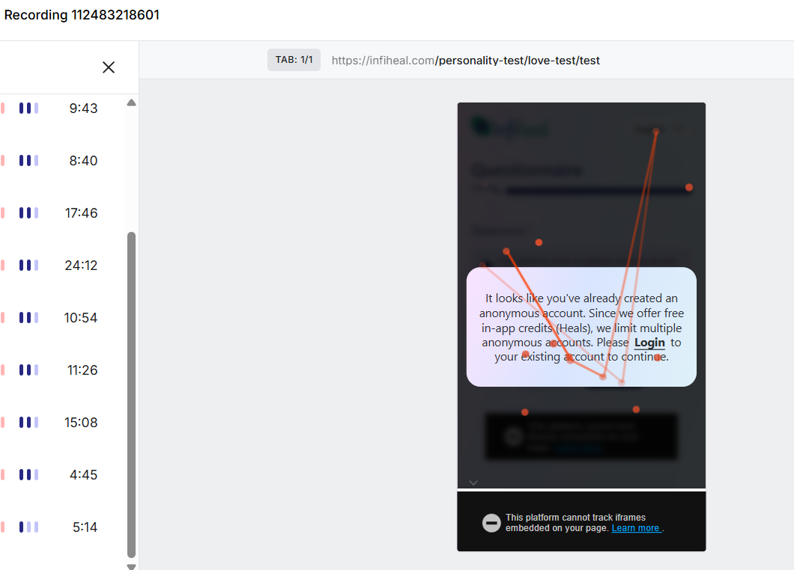

Inkblot is broken — two consecutive days, July 6 & 7, at exactly 55%, down from its 87–103% range in June. Combined with Jul 5's 45%, that's three straight days of deeply underperforming completion.

Metric | Wk 2 Avg/Day | Wk 3 Avg/Day
Tests Started | 17.6 | 20.8
Completion Rate (CR) | 87% | 103%

Metric | Jul 5 | Jul 6 | Jul 7 | Jul 8
SEO Visitors to Test Pages | 366 | 328 | 496 | 422
Users Started Any Test | 168 | 199 | 216 | 177
Users Completed Any Test | 196 | 224 | 232 | 183

A test-attempt-number tag at the event level (e.g., "submit event, attempt #2+") so the dashboard can emit:
- Return users on attempt #1 (haven't used free test yet, or first test overall)
- Return users on attempt #2+ who hit the premium wall
- Of those, how many saw the popup vs clicked Pay Now vs actually purchased
That gives you the real funnel: New signup → Free test used → Returns for test #2 → Hits wall → Sees popup → Clicks Pay Now → Purchases, each step computable without ever touching a user ID, since it's just a count keyed to attempt number, not identity.

